**NAME**: - Jaydeep Solanki

**ROLL NO**: - 22ECG060 | 22BEC059

**COURSE CODE**: - 1CS501

**SUBJECT**: - COMPUTER PROGRAMMING

**PRACTICAL NO 5:** C programs to show the working of arrays.

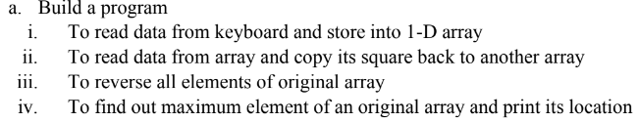

**Code :**

#include <stdio.h>

int main() {

int n, i;

printf("Enter a number of elements : ");

scanf("%d", &n);

int a[n];

printf("Enter the elements of an array : ");

for (i = 0; i < n; i++) {

printf("a[%d]:", i);

scanf("%d", &a[i]);

}

printf("The array is \n");

for (i = 0; i < n; i++) {

printf("a[%d]:%d\n", i, a[i]);

}

return 0;

}

**Output:**

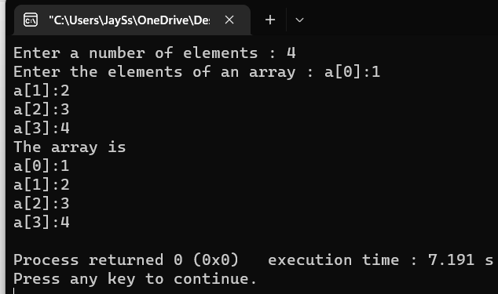

**Code:**

#include <stdio.h>

int main() {

int i, a[5], a1[5];

printf(" Enter the elements of an array \n");

for (i = 0; i < 5; i++) {

printf("a[%d]:", i);

scanf("%d", &a[i]);

}

printf("The square of array is \n");

for (i = 0; i < 5; i++) {

a1[i] = a[i] * a[i];

printf("%d\n", a1[i]);

}

return 0;

}

**Output:**

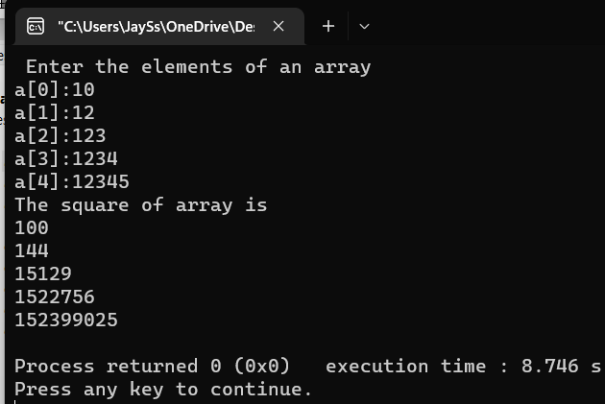



**Code:**

#include <stdio.h>

int main() {

int n, i, j, temp;

printf(" Enter the number of elements \n");

scanf("%d", &n);

int a[n];

printf("Enter the elements of array\n");

for (i = 0; i < n; i++) {

printf("a[%d]:", i);

scanf("%d", &a[i]);

}

j = n - 1;

i = 0;

printf("The reverse array is\n");

while (i < j) {

temp = a[i];

a[i] = a[j];

a[j] = temp;

i++;

j--;

}

for (i = 0; i < n; i++)

printf("a[%d]=%d\n", i, a[i]);

return 0;

}

**Output:**

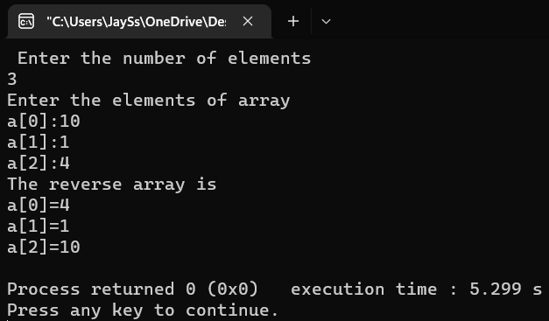

**Code:**

#include <stdio.h>

int main() {

int n, i, j, max;

printf(" Enter the number of elements \n");

scanf("%d", &n);

int a[n];

int index;

printf("Enter the elements of array\n");

for (i = 0; i < n; i++) {

printf("here:-\t");

scanf("%d", &a[i]);

}

printf("The array is\n");

for (i = 0; i < n; i++) {

printf("a[%d]:%d\n", i, a[i]);

}

max = a[0];

for (i = 0; i < n; i++) {

if (max <= a[i]) {

max = a[i];

index = i + 1;

}

}

printf("The max number is %d and the number location is %d", max, index);

return 0;

}

**Output:**

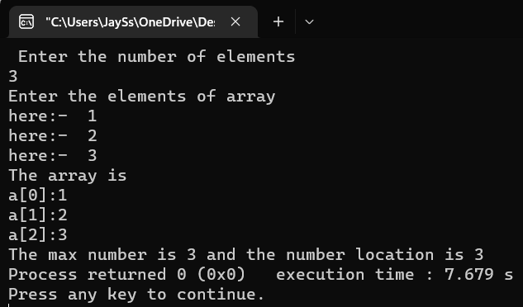

1. Build a program to delete an element from 1-D array.

**Code:**

#include <stdio.h>

int main() {

char arr[100];

int element, num_array;

printf("Enter the number of elements you want in array : ");

scanf("%d", &num_array);

for (int i = 0; i < num_array; i++) {

printf("Enter the element number %d : ", i + 1);

scanf("%d", &element);

arr[i] = element;

}

printf("Enter the number you want to delete : ");

scanf("%d", &element);

for (int i = 0; i < num_array; i++) {

if (arr[i] == element) {

for (int j = i; j < num_array - 1; j++) {

arr[j] = arr[j + 1];

}

}

}

for (int i = 0; i < num_array - 1; i++) {

printf("%d ", arr[i]);

}

return 0;

}

**Output:**

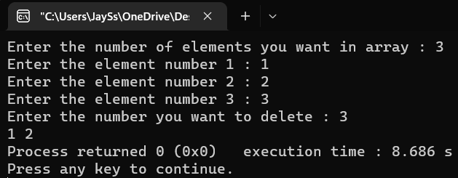

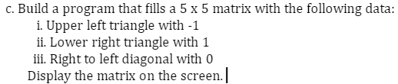

**Code:**

#include <stdio.h>

int main() {

int a[5][5], i, j;

printf("Enter the no of elements of Matrix a of size 5X5\n");

for (i = 0; i < 5; i++) {

for (j = 0; j < 5; j++) {

if (i + j == 4) {

a[i][j] = 0;

}

if (i + j < 4) {

a[i][j] = -1;

}

if (i + j > 4) {

a[i][j] = 1;

}

}

}

for (i = 0; i < 5; i++) {

for (j = 0; j < 5; j++) {

printf("%d\t", a[i][j]);

}

printf("\n");

}

return 0;

}

**Output:**

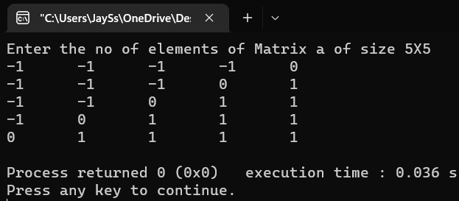

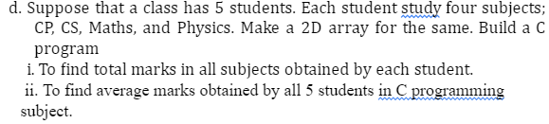

**Code**

#include <stdio.h>

int main() {

int number_of_students, sub = 4;

char arr[100][100];

printf("Enter the number of students: ");

scanf("%d", &number_of_students);

for (int i = 0; i < number_of_students; i++) {

printf("Student %d: \n", i + 1);

for (int j = 0; j < sub; j++) {

int marks;

printf("\t\tSub %d marks: ", j + 1);

scanf("%d", &marks);

arr[i][j] = marks;

}

}

for (int i = 0; i < number_of_students; i++) {

printf("Student %d\n", i + 1);

int total_marks = 0;

for (int j = 0; j < sub; j++) {

printf("\t\tSub %d marks : %d\n", j + 1, arr[i][j]);

total_marks += arr[i][j];

}

printf("\tTotal marks : %d\n", total_marks);

}

int teacher_input, total_of_that;

printf("Average of which subject ?\nEnter the input from 0 to 3\n = ");

scanf("%d", &teacher_input);

for (int i = 0; i < number_of_students; i++) {

total_of_that += arr[i][teacher_input];

}

printf("The average marks of the class is %d :",

total_of_that / number_of_students);

return 0;

}

**Output:**

